Team Project 01

Team Members
Trey Holthe
Andrew Ingle
Jeff Maxwell
Reagan Meagher

Guess, You Must is a different take on the classic Hangman or Wheel of fortune game using Star Wars characters. You can score points by guess letters and numbers for a character and bet different amounts for each guess.

Ideas and Brainstorming
We wanted to add a fun twist to the project so decided to go with a Star Wars based theme and use Star Wars characters as the words/names to guess. We also wanted to put the points wagered into the hands of the player, so we decided to allow them choose how much they bet on each letter so if they were more or less confident on the next guess they could adjust their wager accordingly. Everyone pitched in on ideas and we feel like we have built a fun and interesting game.

NOTE: We know we have used Star Wars character names, logos and other Star Wars related items without approval of Disney, so we wouldn’t be able to publish this to the app store but could be a fun game to share with friends.

Rules of the Game
- Splash Screen
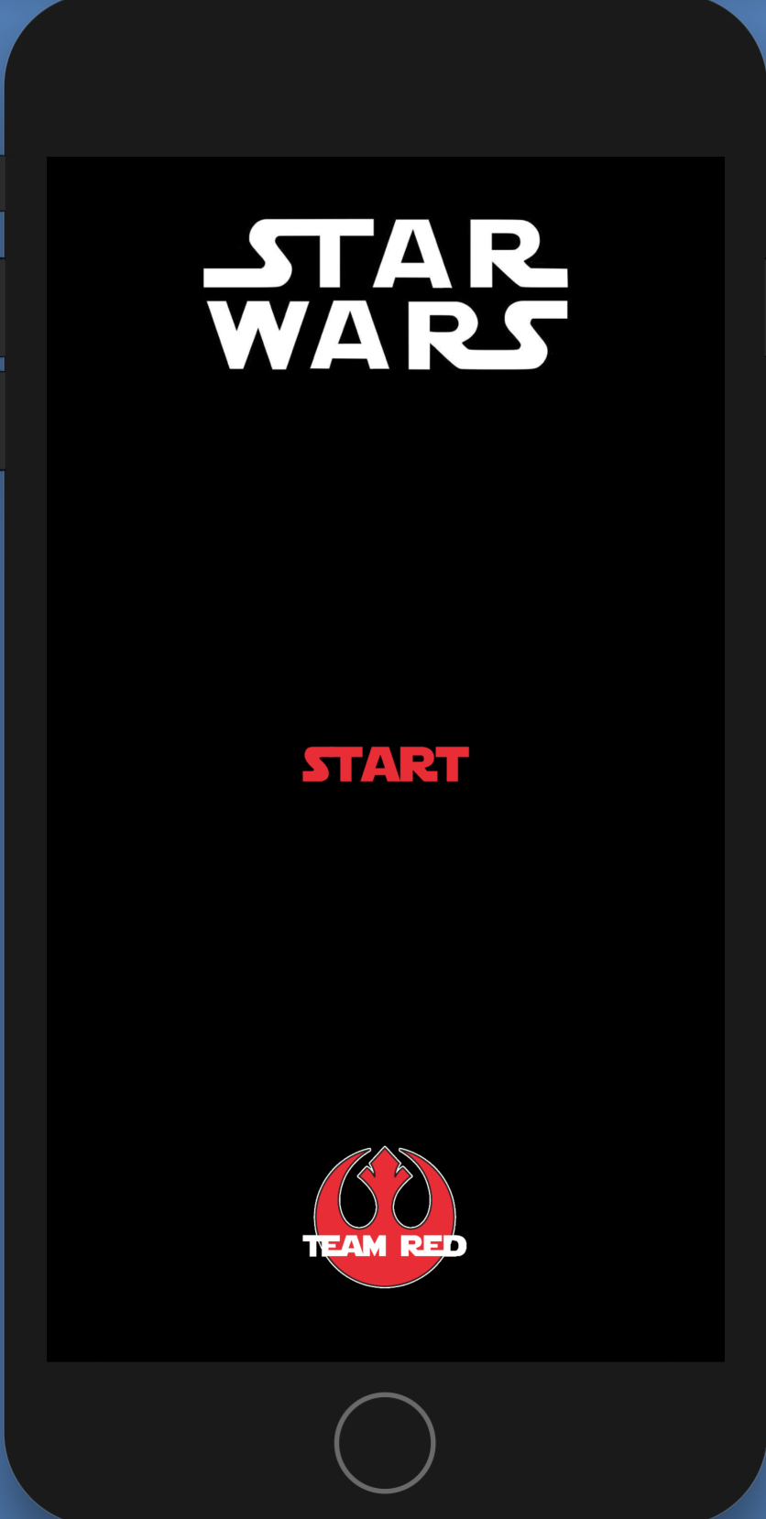
- Touch “Start” to continue to the Game
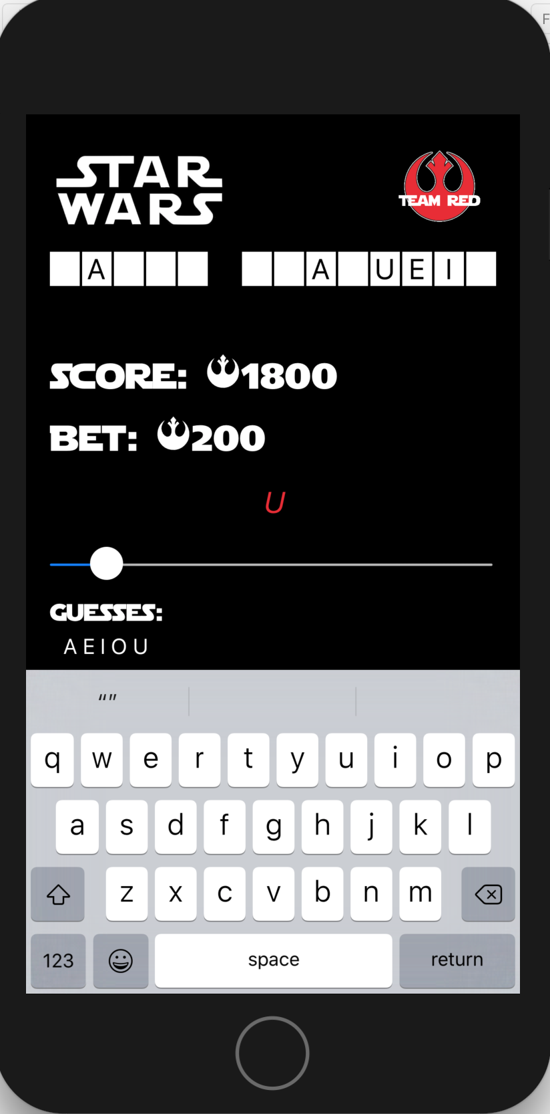 | - At the start of the first game Score is set to 1000  - When the game starts a Random Star Wars Character is seleted.  - As the user types letters in the keyboard  - Letters are added to the Guesses List  - Letters are checked for matches  - If there is a match the letter is shown, and the score is increased by the amount that was bet  - If there is no match the score is decreased by the bet amount

- Game Over

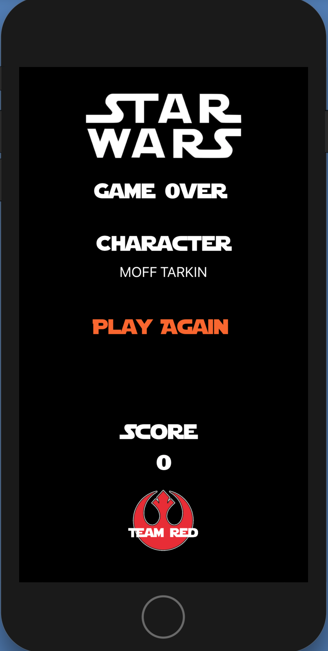 | If your score goes to Zero (0) then the game is over.  You can touch “Play Again” to start a new game and it resets your score to 1000 | 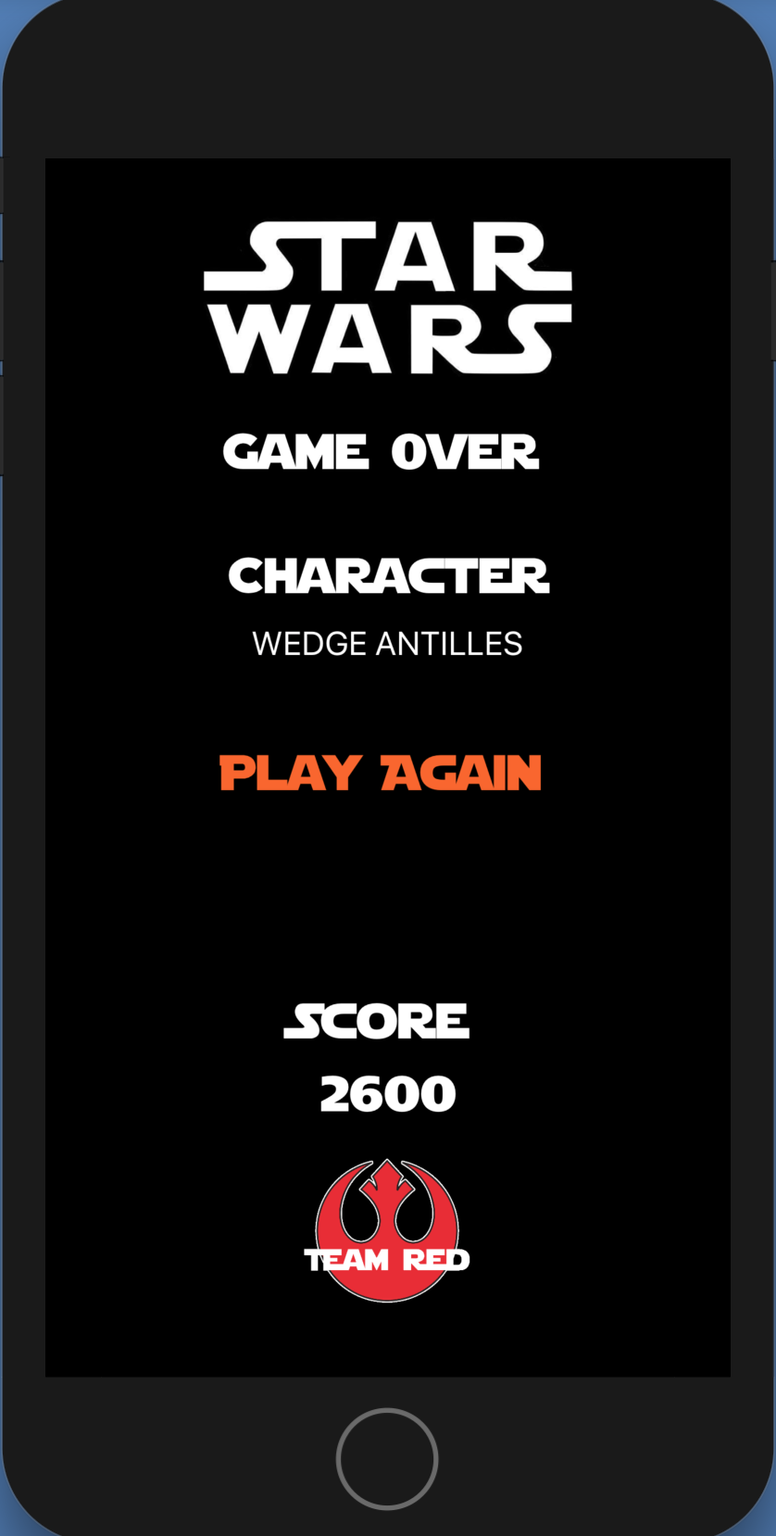 | If you guess all the letters correctly then the game is over.  You can touch “Play Again” to play another round and you continue with your current score.

Project Tasks
There were a variety of tasks needed for this project and different team members did several different tasks here are some of the highlights.
- Team Logo – Andrew
- Star Wars Font – Andrew
- Word Bank and Random selection of word – Andrew
- Letters Guessed list – Andrew
- Score – Trey
- Bet – Trey
- Slider for Bet – Trey
- End Game – Reagan
- New Game – Reagan
- Create Dynamic Labels for word – Jeff
- Match letters guessed to word – Jeff
- Layout of 3 ViewControllers and Segues – Jeff

There were a lot of other little tasks and clean up that the team fixed as needed.

References

Graphics:
- Star Wars Logo - https://worldvectorlogo.com/logo/star-wars-2
- Rebel Red Logo - http://www.brandsoftheworld.com/logo/rebel-alliance
- Star Wars Font - http://www.fontspace.com/boba-fonts/star-jedi
- Darth Vader Silhouette - http://getdrawings.com/darth-vader-silhouette#darth-vader-silhouette-9.jpg

Code:
- Ray Wenderlich - https://www.raywenderlich.com

